**RXFA Trading Panel**

**Complete Guide**

* What is the RFXA Trading Panel?

The RFXA Trading Panel is a tool provided by RockzFX to the members of the RockzFX academy. It provides complete automation for entering trades, risk management and trade management according to the rules of the RockzFX strategy.

To use the panel, you would need to have MT4 installed on your laptop/PC.

Disclaimer:

By installing and using this panel, you accept that RockzFX and Ahmed Elmoghazy and overall, RockzFX Academy is not responsible for the results you get whilst using the RFXA Trading Panel. This has been offered to you to use as a member of the RockzFX Academy and you take full responsibility for any actions you take, and any results you get whilst using the RFXA Trading Panel.

**Installation Guide:**

Navigate to the #rockzfx-academy-resources channel in slack. The latest version of the installation file will be available for download.

Download the file and save it somewhere you can easily access.

Open up MT4, click on File and select Open Data Folder.

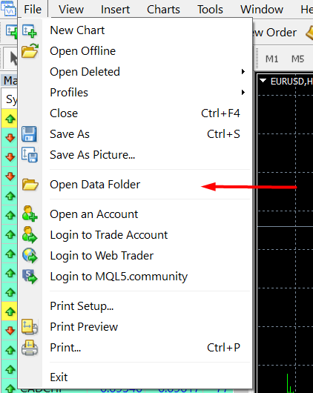

A new folder should open up. Navigate to MQL4 then to Experts. In the Experts folder, put in the file that you downloaded earlier from the slack channel.

Close MT4 and open it up again.

Make sure that AutoTrading is turned on.



To add the panel to the chart, go the Navigator to the left. Open up Expert Advisors and there you will see RFXA Trading Panel v3 (or something similar).

If you don’t know where the Navigator is click on Ctrl+N or go to View and select Navigator.

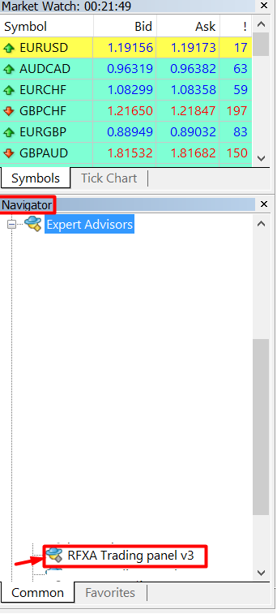

Drag and drop it to the chart.

In the Common tab, make sure that Allow live trading is checked.

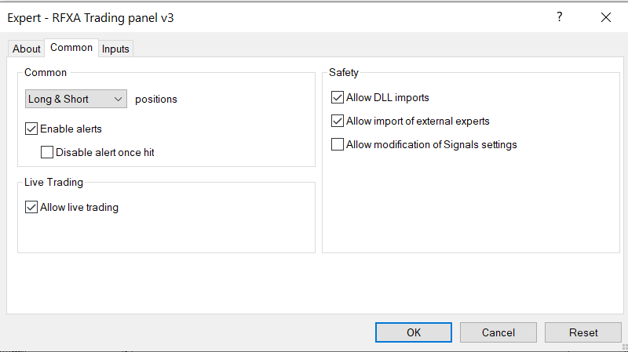

Go the Inputs tab:

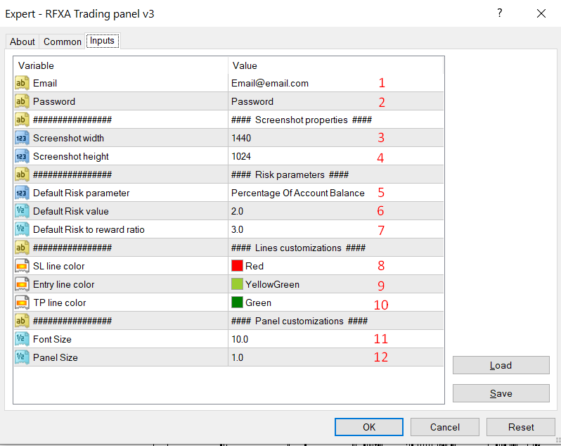

In this page, you will customize the panel to personally fit you.

1. Enter your email you used to register in the RockzFX Academy.
2. Enter the password provided to you in the slack channel #rockzfx-academy-resources. The password is renewed each month so keep an eye for it. If the password is incorrect or expired, you will get an error message stating that. Only members of the academy are allowed to have the password.
3. And 4) Adjust the width and height of the screenshot when using the screenshot option in the panel. The default values work fine. If you have a large or a small monitor, you might need to adjust those values accordingly.
4. Risk management part. When entering a trade, you have the option to either risk a certain percentage of your balance or risk a fixed amount of money. In this field, choose your preferred mode (percentage or fixed amount of money).
5. Depending on your choice in 5, choose the default value for the risk. If you chose percentage, select here your preferred risk percentage per trade. If you chose to risk a certain amount of money, select here your preferred amount to risk per trade.
6. Choose your preferred risk to reward ratio. The default RRR for the strategy we use is 3. But you may change it as you wish.
7. 9) and 10) Choose the colors of the lines that are used by the panel.
8. and 12) Adjust the size of the panel and font size to fit your screen.

After you are done with inputs, press Ok.

**Using the Panel:**

**Entering a trade:**

After pressing Ok, the panel should load up on the left of the chart window.

The panel is divided into 3 parts: Trade entry, risk parameters, trade management parameters.

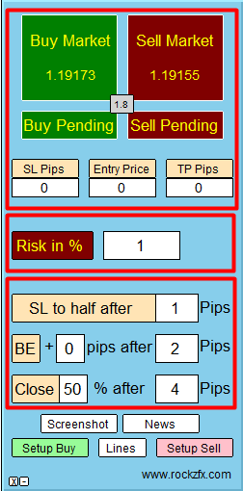

Firstly, make sure the risk parameters are correct. Check whether you are using % or $ to risk and check the value you are risking.

Secondly, the panel is Lines-based which means that the lines need to be visible on the chart in order for the trade to go through.

Click on Setup Buy or Setup Sell to bring up the lines on the chart.

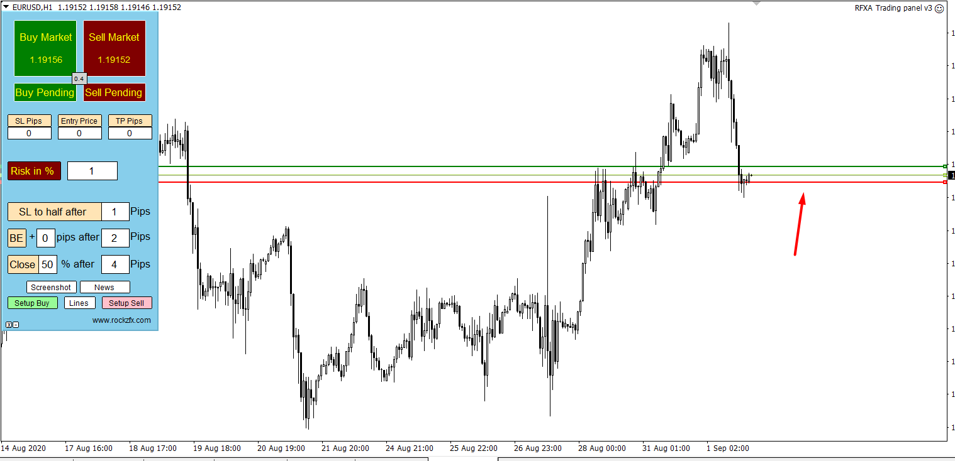

The colors of the lines will correspond to the colors you selected in the inputs earlier (8,9,10).

Adjust the entry line, SL line however you wish to enter the trade. TP line is adjusted automatically according to your input entry (7). You have the choice to enter the market instantly (market order) or with a stop/limit order (pending order).

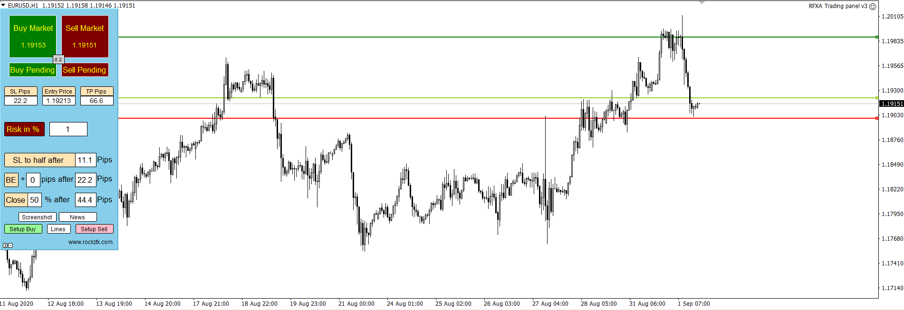

In this example, I am looking to enter the market with a buy stop order. Entry line is placed above price, SL is placed where I wish for it to be and TP was adjusted automatically to 1:3. Satisfied with these parameters, I will click on Buy Pending to send the buy stop order to the terminal.

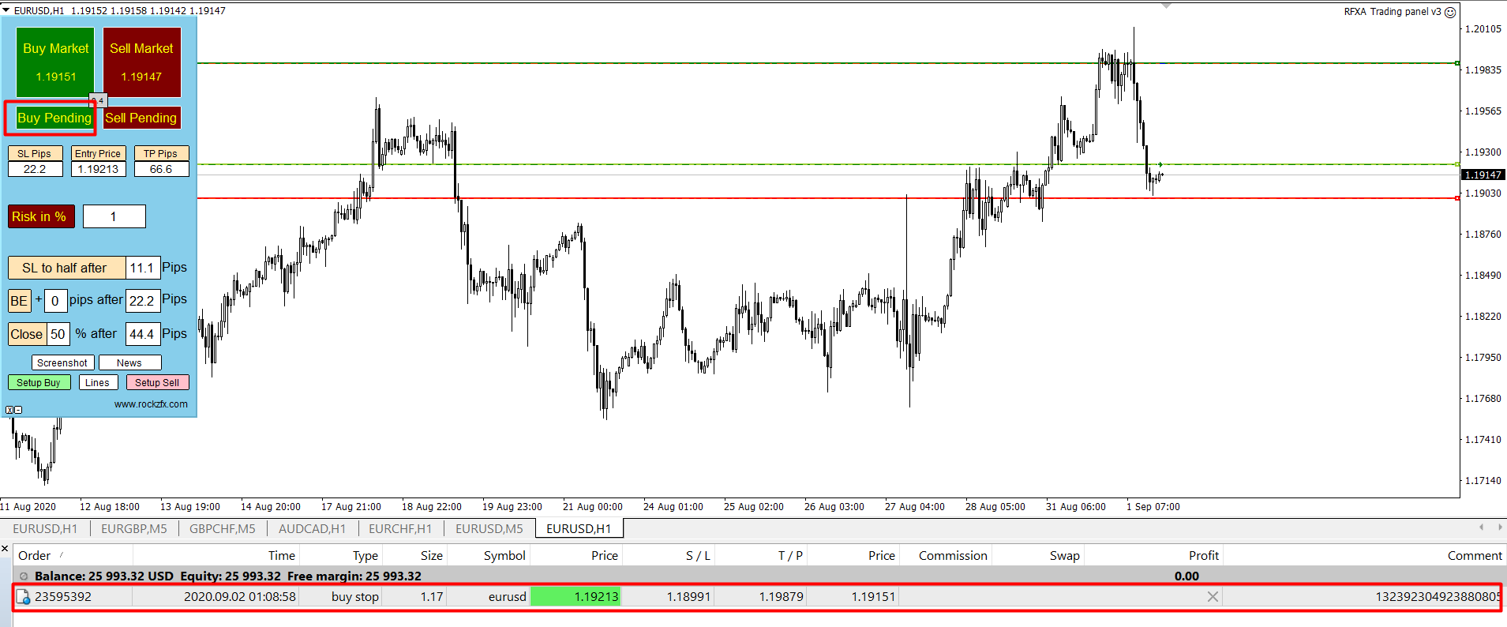

Order placed successfully.

This method is valid for all other order types as well. If your entry line is below price, the panel will automatically detect that you are looking to enter with a Buy Limit order and send the order accordingly.

Take your time on a demo account to get used to placing the lines and entering the orders!

**Trade Management:**

The other part of the panel is the trade management section. You have the option to reduce your SL to half, go BE or take partials.

The default value for SL to half is 1:0.5, for BE is 1:1 and for closing partials is 1:2. In the previous example, we can see that our SL was 22.2 pips. SL to half was automatically calculated to be 11.1 pips (1:0.5), BE after 22.2 pips (1:1) and 50% off at 44.4 pips (1:2). You can manually change the pip numbers and the % to be closed as you wish.

The trade management is not activated by default. To activate each function, press on the corresponding button. When activated, it will change to Green.

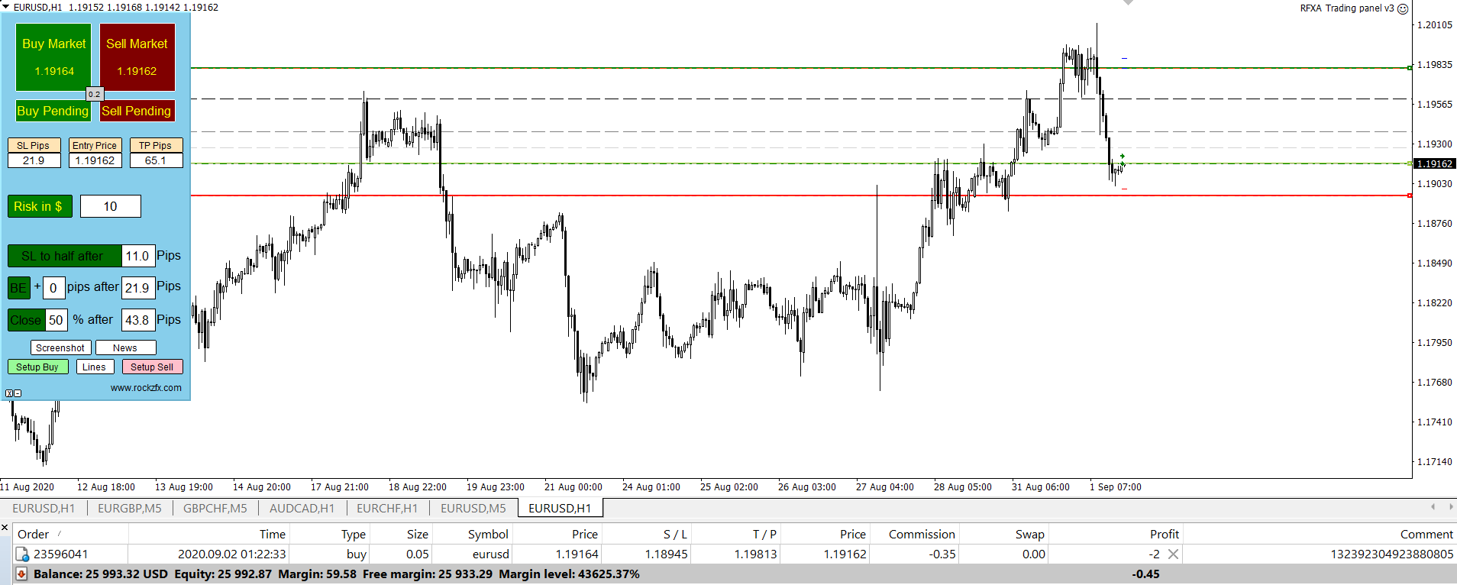

In this example, I entered an instant execution (by pressing on Buy Market), risking 10$ on this trade. I then pressed on the trade management buttons. When activated, they turn to Green and the corresponding lines appear on the chart as dashed lines.

To deactivate them, press on the buttons again. The button should return to its original color.

**Activating the News:**

The panel has the option to show the news for the week as lines on the chart. To activate the News function, first you’ll need to add the website to the trusted websites on MT4.

Go to Tools – Expert Advisors. Check on Allow WebRequest for listed URL and add the following URL to the list:

<http://ec.forexprostools.com/?columns=exc_currency,exc_importance&importance=1,2,3&calType=week&timeZone=15&lang=1>

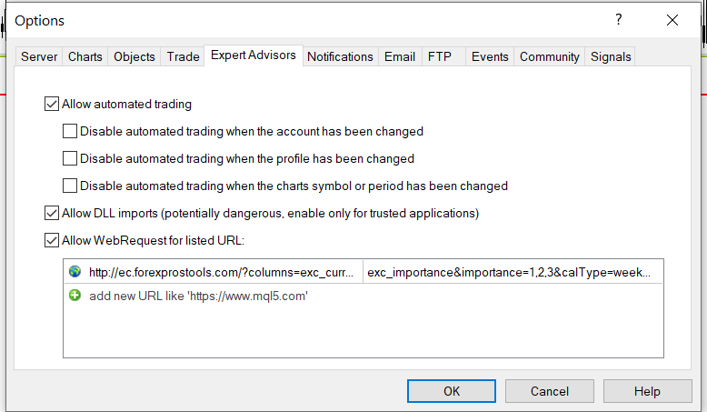

Having done this step, you can press now on News on the panel and select which News would you like to show.

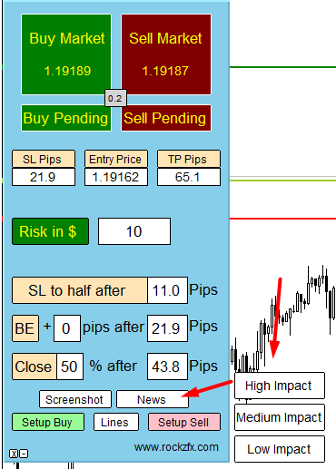

**Taking a screenshot:**

Clicking on Screenshot on the panel will take a screenshot of the current chart window. The screenshots are saved in MQL4/Files/Shots folder. To access this folder, click on File – Open data folder.